**Assignment 2**

**Requirements:**

**Part 1**

**Apply averaging filter, Sobel filter, Laplacian filter, median filter to one or some of your own images. Show the original image and filtered images.**

**You are NOT required to analyze the different effects of the filters, just observe and show your results in the report. You could choose any kernel for a certain type of filter (kernels with different kernel sizes, negative or positive center etc.).**

**Part 2**

**Find the boundary of the pupil.**

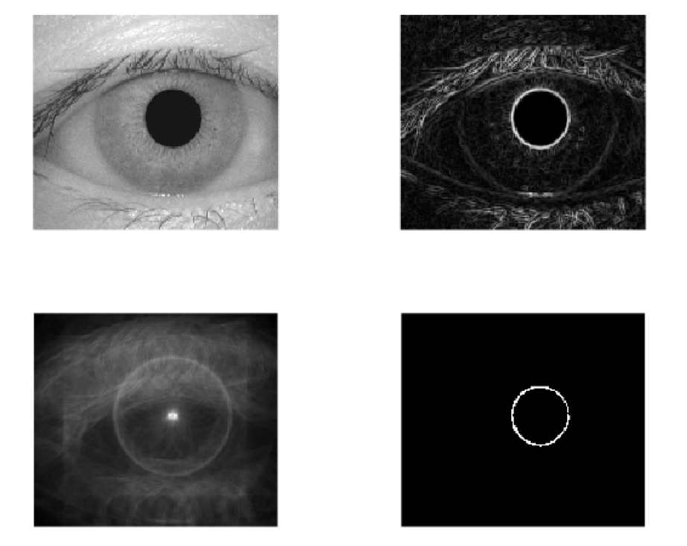

1.Apply the sobel filter to detect the edge information (both vertical and horizontal edges) of the image “iris.bmp”.

2.Try the filtering/correlation techniques to detect the boundary of the pupil, given the radius of the boundary circle is within range 15~25. (You could first detect the center of the pupil and remove noise that is far away from the pupil center.)

3. Show your Sobel filtered result, center result and the final detected pupil boundary result.

**4. Matlab(or any other programming language) library function(s) that detects the circle automatically is/are not allowed! (e.g. imfindcircles())**

**Submission:**

1. Your report (include the figures, analysis and conclusions.) ***4 points***
2. A compressed (please use “zip” file) file including all the code files and source images, output images. ***6 points***